Calvert Green Neighbourhood Plan
Village Consultation Document

HAVE YOUR SAY… Your Parish. Your Plan. Your Choice.

Voting Deadline: Friday 12 November 2021
One vote per household - Go to: https://forms.gle/99xMSHwpRN3riARx6

SAVE THE DATE!
There are two events organised to learn more, ask questions, and input your views:
- Saturday 23 October 2021 at 4:00pm (Calvert Green Village Hall)
- Wednesday 3 November 2021 at 7:30pm (via ZOOM)
https://us06web.zoom.us/j/85365184453?pwd=RUNpUmk1aDFoaXMyZVV3RndybnR1UT09
Meeting ID: 853 6518 4453 / Passcode: 788534
(if you want the link sent to you please email: liza@calvertgreenparish.co.uk)
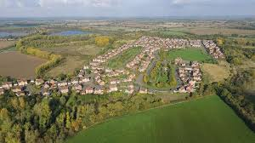

Our Mission

To sustain and grow a safe and caring and vibrant community by representing and serving the best interests of those who live within or invest in it.

Introduction
Calvert Green Parish Council has started the process to develop a Neighbourhood Plan. A Neighbourhood Plan is an important and powerful tool giving communities statutory powers to shape how their communities develop. With so much land around Calvert Green belonging to developers, it is vital that we undertake this process NOW so that WE as a community have an increased influence in any future development within our village.
Preface
Once developed, a Neighbourhood Plan is a document which sets out planning policies for the neighbourhood area – these planning policies are used to decide whether to approve planning applications in the future.
To enable the formation of a Neighbourhood Plan for Calvert Green, the Neighbourhood Plan Steering Group (NPSG) was formed from volunteers within our community. Over the past few months, the Steering Group has examined the possibilities and with the help of professional planning consultant, Neil Homer of Oneill Homer, has created this document as a next step in the process towards creating the Neighbourhood Plan.
The following document is to advise residents of the available options. After this consultation we will select one of two paths outlined in this document and the NPSG will work to create the draft Neighbourhood Plan.
This document begins by defining our Neighbourhood Plan area, sets out the challenges and outlines any specific opportunities and concerns. It also describes in detail the two possible options identified and the pros and cons of each.
The first appendix describes our overarching Neighbourhood Plan objectives identified by the Neighbourhood Plan Questionnaire of July 2020 completed by 25% of residents and outlines our overall Vision Statement.
The second appendix gives a brief history of Calvert Green and its formation and serves as a useful reminder of the intended ethos of our village. It is worth reading, especially for those residents who are relatively new to the village!

Neighbourhood Plan Area
In line with current regulations, a Neighbourhood Plan requires a designated ‘neighbourhood area’. The map below shows the land included in this, all of which will be considered within Neighbourhood Plan. As can be seen, Calvert Green is included, together with part of Calvert Jubilee Lake, a local SSSI (Site of Special Scientific Interest) to the southeast and landfill sites to the south.
With additional permission gained by Charndon Parish Council, the land to the north of our parish falling within their parish has also been included in the designated Neighbourhood Area, as any future developments in this area will affect Calvert Green and so increase the social, economic and environmental demands made on our village. Including it allows Calvert Green Parish Council direct involvement with any future planning applications.

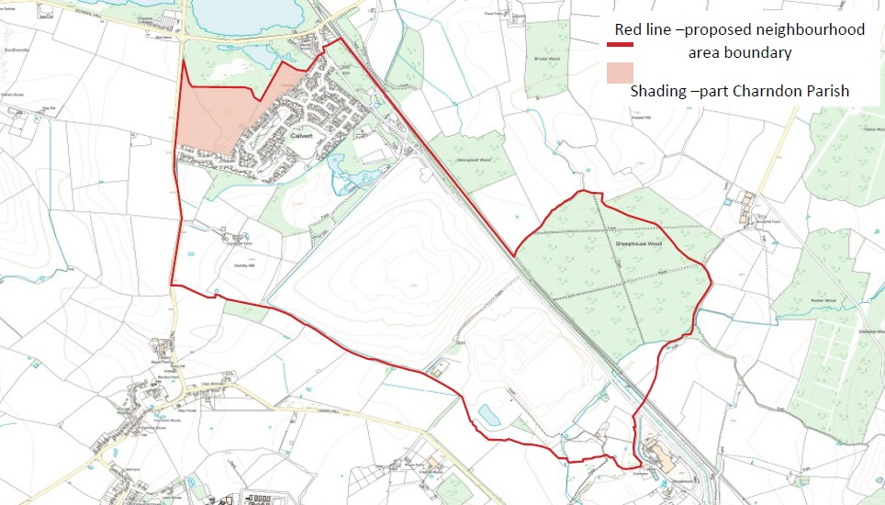

Identified Challenges and Concerns
Challenges
Calvert Green faces several challenges from current major infrastructure schemes, proposed large government projects and continued detrimental effects on surrounding roads and environment:
- HS2 line and maintenance depot – both are sited close to the parish – impact of the construction, increase in HGV traffic and subsequent operation.
- HS2 concrete batching plant – questions over its long-term future.
- EWR – impact of construction, HGV traffic and subsequent operation.
- EfW (energy from waste) incinerator – visible across the parish and wider area plus significant HGV traffic on local roads.
- Proposed mega prison at Grendon/Edgcott – cumulative effects on environment, HGV traffic and safety concerns.
- Dunsty Hill Farm – rural exemption site scheme and insecurity over future planning applications.
- Solar farm – on previous landfill site.
- Past planning proposals – for land to the north of Calvert Green Parish by Persimmon and David Wilson Homes – within Charndon Parish but included in Calvert Green Neighbourhood Area.
- Calvert City – new large town concept visualised to be located along the Oxford /Cambridge arc subsuming Calvert Green. Since the apparent abandonment of the expressway, this may be relocated closer to existing major road / railway projects.

Concerns
The concerns facing Calvert Green are outlined below:

- Effects of major infrastructure projects on the village.
- Little social infrastructure.
- Poor connectivity – public transport, cycle routes, etc.
- Lack of local support systems / healthcare – residents largely must use their own cars or privately funded transport to connect with schools, doctors and healthcare, shopping, sport, and leisure facilities etc.
- Reliance of support services from local villages which are themselves. expanding and which, therefore, may have decreasing catchment areas.
- No real ‘heart’ to the village as everyone must travel outside the parish for work etc. due to the remote location.
- Not a self-supporting community – everything is sourced from outside the parish.
- Road damage caused by HGVs make cycling unsafe.
- The absence of a primary school / day nursery - even though the parish has a higher-than-average number of school-aged children for a rural area.
- Over capacity levels at local doctors’ surgery.
- Small, incremental housing schemes may have a large impact on the community.

Looking to the Future
The neighbourhood of Calvert Green has now reached a critical point where a decision needs to be made on what form that future will take and difficult choices now need to be made.
Creating our Neighbourhood Plan enables villagers, the Parish Council, the NPSG and other key stakeholders and interested parties to combine ideas and information, gathered through this process, to formulate a SMART and ACHIEVABLE vision for our future.

In simple terms, we have two options to explore further. We can create a Neighbourhood Plan which either:
OPTION A: focuses on a small number of policies to protect our existing surroundings and environment, with the potential to safeguard landscape buffers to the north and south of the village;
OR…
OPTION B: chooses to adapt and grow the village, incorporating planned expansion and increase in population, allowing us opportunity for future improvements and development of our infrastructure and services.

WE NOW NEED TO DECIDE WHICH OPTION TO EXPLORE
…….SO PLEASE KEEP READING.
Options for the Calvert Green Neighbourhood Plan

Option A: Protecting the Existing Environment
Option A - Advantages
- The Neighbourhood Plan would be simple but unambitious.
- There would simply be a small number of policies to protect the established environment.
- Public open spaces would be designated as Local Green Spaces affording them the same protection as Green Belt land.
- New large-scale projects may improve connectivity, but this cannot be guaranteed.
Option A - Disadvantages
- Calvert Green would remain the same with no investment in new or existing infrastructure
- Small areas of additional housing could be added in an unplanned, haphazard fashion.
- Speculative planning applications would have to be monitored closely.
- Irrespective of the Neighbourhood Plan, large government projects could nonetheless dictate extensive housing developments, without regard for the county council, parish council or residents’ wishes or plans.
- As surrounding villages increase in population, catchment areas for local schools may decrease, leading to insufficient places for Calvert Green children.
- The Neighbourhood Plan may prove an ineffective defence if the Buckinghamshire Local Plan includes a need for additional housing in this area.

Option B: Planning for Expansion
Option B - Advantages
- One overall expansion masterplan dictated by the Neighbourhood Plan and not by speculative developers.
- Planned developments could bring with them benefits associated with an increase in population, e.g., day nursery, early years learning, better medical facilities provision etc.
- Potential small increase in commercial units, e.g., offices, café, public house, retail units.
- Potential improvements to sport and leisure facilities.
- Securing a network of new publicly accessible woodlands and open spaces to surround the village which would complement the existing green infrastructure and provide an effective visual buffer around the entire village so that no existing properties are adversely affected.
- Create a budget for investing in local green travel projects, e.g., Community-led bus service, cycling routes etc.
- Planned expansion divided between several small- and medium-sized house builders instead of one volume builder, across several small- to medium-sized pockets of land.
- Potential for self-build or custom build projects.
- Any new development would sit within the designated green network to preserve the identity of the entire village.

Option B - Disadvantages
- Increase over ten years of approximately 800 additional houses and from 1,200 residents to 2,000-2,500 residents to support new ventures.
- Potential change in the character of the village due to its increased size.
- Increase in disruption during building phases, in addition to the disruption and noise from current on-going projects and potentially the local mega-prison project if it goes ahead.
- Large government projects could nonetheless dictate extensive housing developments, without regard for the county council, parish council or residents’ wishes or plans.

DIAGRAMS
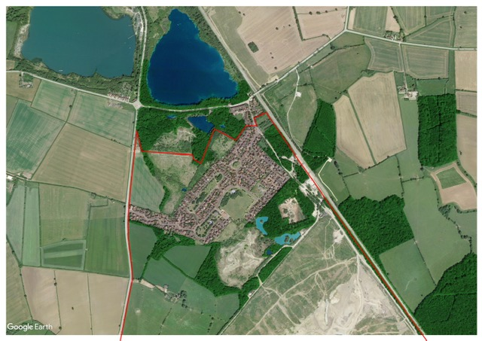

This diagram shows how the geography and existing green infrastructure (GI) of the village allows for growth to be accommodated in a series of smaller development pockets, set within that GI, bolstered by major improvements:

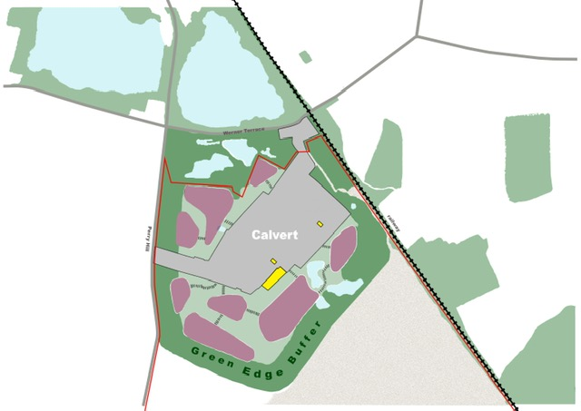

Appendix I: Neighbourhood Plan Objectives
Using the results of the Calvert Green Neighbourhood Plan Village Questionnaire delivered to every house in July 2020 and completed by 25% of households, the NPSG identified the following list of key objectives and deliverables considered for inclusion in our Neighbourhood Plan:
- Continue to support and improve the Parish Council’s responsibilities which include:
- village greens and play areas
- seeking to improve the highway infrastructure
- seeking to improve and maintain local beneficial facilities
- enhancing community safety and reducing fear of crime
- Support the CGCA (Calvert Green Community Association) to provide social events, activities and spaces where residents of all ages can come together and participate in sports, social, wellbeing and other leisure activities as well as access to the services of the Parish Council.
- Establish a Neighbourhood Plan for the village which protects the rural nature of the village whilst recognising the potential housing, education and infrastructure needs of residents in the future.
- Ensure that future planning applications reflect and meet long term challenges in the area.
- Ensure all our geographical and natural assets are identified, promoted and protected so that they are preserved for the future of the village.

Following these key objectives identified, we created the Calvert Green Vision Statement:
- We should be a safe, healthy, clean and caring place where people want to live for the long term.
- We should be inclusive, promoting a strong sense of community spirit every day and in every way.
- We need to be well connected with local transport and communication links fit for the future.
- We need to protect the village character, its unique environment, and our open spaces.

Appendix II: History of Calvert Green
Calvert Green is built upon the site of a former brickworks run by The London Brickwork Company.Their operation at Calvert was the second largest of its kind in the country when it opened in 1900, with over 1,000 workers in its employment, almost entirely from the surrounding villages. At its peak, the company was producing around 40% of Britain’s bricks.
In 1991, the brickworks closed and most of the buildings were demolished over the next four years. The land remained derelict until Persimmon and David Wilson Homes were given planning permission to revitalise the land with the creation of a new village.
The name Calvert originated from the Calvert-Verney family, before Sir Harry Verney inherited the family estate at Claydon House, Middle Claydon, Buckinghamshire. The Jacobean manor house, donated to the National Trust in 1906, was built in the mid 1700s by Lord Verney and is still occupied by Sir Edmund Verney, 6th Baronet Calvert.
Originally intended to be the perfect location for families who wanted tolive in the countryside and enjoy a rural life, Calvert Green was designed to be a village with most of the expected usual amenities: village hall; village green; local shop; various recreation areas. Every consideration was given to the visual aspect of Calvert Green when Planning Consent was granted and the village was to be constructed around ‘identity areas’ – areas of landscaped open spaces where residents could congregate and relax with the additional asset of a large nature reserve, Calvert Jubilee Lake, run by BBOWT adjacent to it.
Since the original 302 houses were built in 2001-2004, a further four homes were added on the site originally designated for a local shop, with 98 homes (The Steeples) added in 2012/2013 on land previously set aside for business use and to provide local employment, bringing the current population to approximately 1,200 residents. The village hall was recently extended to include a larger kitchen, a bar and improved bathroom facilities. The local shop opening coincided with the completion of the newest dwellings. Approximately 35% of the houses are designated as social housing, which equates to approximately 140 homes.

NOW HAVE YOUR SAY… Your Parish. Your Plan. Your Choice!
Voting Deadline: Friday 12 November 2021
One vote per household - Go to: https://forms.gle/99xMSHwpRN3riARx6
SAVE THE DATE!
There are two events organised to learn more, ask questions, and input your views:
- Saturday 23 October 2021 at 4:00pm (Calvert Green Village Hall)
- Wednesday 3 November 2021 at 7:30pm (via ZOOM)
https://us06web.zoom.us/j/85365184453?pwd=RUNpUmk1aDFoaXMyZVV3RndybnR1UT09
Meeting ID: 853 6518 4453 / Passcode: 788534 (note: this link is also on the PC website)
(if you want the link sent to you please email: liza@calvertgreenparish.co.uk)

